

Master of Science in Nursing (MSN)

MENTOR HANDBOOK

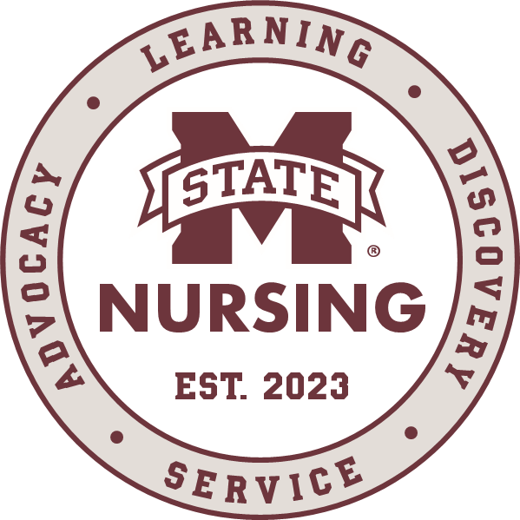

Dear Nursing Mentor,
Thank you for mentoring a student from the Mississippi State University (MSU) School of Nursing. You will be a role model for nursing students in planning, providing, and evaluating patient care. You will help students develop clinical skills and ensure safe patient care.
Mentees are expected to participate in patient care at a level appropriate for their education and competence. You will receive specific guidelines for each course and/or semester. We encourage you and your mentee to establish clear plans for clinical responsibilities and expectations.
While you maintain responsibility for patient care, faculty oversee student evaluation and support the mentor-mentee partnership. MSU faculty will collaborate with you to monitor progress through site visits, conferences, and student clinical assignments. Faculty are also available between visits to support you and your mentee.
If questions or concerns arise, please contact the student’s assigned clinical faculty member or the School of Nursing office at (601) 696-2214.
We appreciate your dedication and support for MSU nursing students!
Sincerely,

Mary W. Stewart, PhD, RN, CNE, FAAN
Dean and Professor
MSU School of Nursing

“Taking care of what matters to the many diverse people and communities we serve has always been Mississippi State University’s mission. Our students are at the heart of everything we do, and we are committed to preparing them and helping them as they grow into the future leaders our state and nation need.”
-Dr. Mark Keenum, President of Mississippi State University

Table of Contents
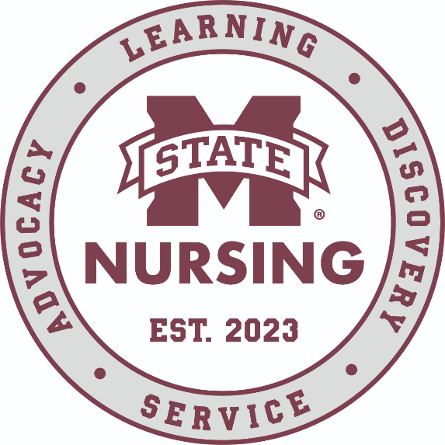
Introduction 4
Nursing Mentor Policy 4
Roles and Responsibilities 5-6
Guidelines re: Skills Performance by MSN Students 7
Frequently Asked Questions about Mentoring 8-9
Student Health 10

Introduction
The Mississippi State University School of Nursing (MSU-SON) is at the forefront of nursing education. The accelerated Master of Science in Nursing (MSN) program offers a pathway into practice as a Registered Nurse for those with a previous degree in a non-nursing field. In this pre-licensure program, students are prepared for entry-level direct patient care.
We leverage the skills, knowledge, and life experiences that each student brings as a scaffold for nursing practice. We strive to create a community where every student belongs, questions are welcome, and learning is active. At the end of the 12-month, 58 semester-hour program, graduates will be eligible to take the NCLEX-RN.
Please visit our website at: https://www.nursing.msstate.edu/.

Nursing Mentor Policy

A clinical mentor is a qualified RN and employee of an affiliated agency who works one-on-one with nursing students in the clinical area to promote learning. The mentor is willing to dedicate time, attention, and expertise to the student nurse (mentee) to facilitate achievement of clinical objectives. Mentors shall have:

- At least one year of practice experience as a Registered Nurse.
- An unencumbered license to practice in Mississippi or hold a multistate license from another NLC state.
- Completed mentor orientation and signed agreement/s.

In collaboration with the clinical agency, MSU nursing faculty determine the appropriate mentorship experience for students. Nursing faculty are responsible for developing guidelines that are specific to the course for the mentor and mentee to follow. Mentors do not replace nursing faculty but work closely with nursing faculty to promote student success. Nursing faculty are responsible for completing the formative and summative evaluations of the student.

Roles and Responsibilities

Nursing faculty
- Work with clinical agencies to identify nurse mentors.
- Assure mentors receive the handbook, complete orientation, and sign required agreements prior to initiating mentorship.
- Share scheduling details with the mentor and exchange contact information.
- Verify student compliance with agency and program requirements prior to entering the clinical setting (e.g., BLS certification, vaccinations, malpractice insurance).
- Pair students with mentors.
- Hold responsibility and accountability for appropriate clinical learning experiences.
- Communicate the student’s skill level and course expectations to the mentor.
- Collaborate with the mentor to supervise and assess student performance.
- Meet regularly with the clinical mentor to monitor and evaluate clinical experiences.
- Conduct a minimum of two formative evaluations/course for each student.
- Invite feedback from the mentor regarding student clinical performance.
- Establish methods of communication with the mentor and respond to mentors within a timely manner.
- Communicate to students the expected clinical objectives, number of hours required, and other course expectations related to the clinical experience.
- Evaluate student progress through rounds, conferences, and review of student clinical assignments.
- Make regular, periodic visits to the clinical agency.
- Complete evaluations.

Agencies
- Confirm availability of mentors.
- Retain ultimate responsibility for the care of patients.
- Retain responsibility for the mentor’s salary, benefits, and liability.
- Provide basic information about the agency’s expectations of mentors.
- Interpret the mentor program and expectations of students to other agency personnel who are not directly involved with mentorship.
- Ensure that during clinical learning experiences, students are not utilized for health care facility staffing or accounted for in staffing ratios.

Students
- Determine the mentor’s preferred method of communication and exchange relevant contact information.
- Work with the mentor to establish a conflict-free, clinical schedule. Student vacations, family events, etc., are not acceptable conflicts.
- Submit the planned clinical schedule to assigned SON faculty/staff.
- Communicate any change in the clinical schedule to the faculty and mentor.
- Record clinical time and patient encounters, as instructed by course faculty.
- Contact faculty through means outlined in the course syllabus.
- Retain responsibility for knowing and communicating expected clinical objectives, number of hours required, scheduling, and course expectations.
- Always comply with agency and program requirements.
- Notify faculty early if they anticipate a problem completing required clinical hours, due to the mentor’s schedule.
- Complete required agency and school orientation(s).
- Maintain open communication with the mentor, faculty advisor, and course faculty.
- Prepare for each clinical experience and demonstrate readiness to learn in clinical.
- Hold accountability for their actions and learning in the clinical setting.
- Arrange for mentor supervision when performing patient care, as necessary.
- Respect the confidential nature of all information obtained in the clinical experience.
- Adhere to safety principles and legal standards in the performance of nursing care.
- Maintain professional behavior, e.g. civility, attendance, punctuality, and communication during clinical experiences.
- Adhere to guidelines in the MSU-SON Student Handbook regarding clinical expectations, e.g., uniforms, behaviors, and attendance.
- Demonstrate a humble, curious, and courteous attitude during clinical experiences.

Mentors
- Complete mentor orientation and required forms.
- Collaborate with students and faculty to create a clinical schedule.
- Document the student’s attendance.
- Retain responsibility for the care of patients.
- Orient the student to the clinical unit/setting.
- Guide, facilitate, supervise, and monitor the student in achieving clinical objectives.
- Supervise the student’s performance of nursing activities, including patient teaching, in a manner that ensures safe practice.
- Provide direct, timely, and respectful feedback to the student regarding clinical performance.
- Assess student performance.
- Collaborate with faculty to review student progress of clinical learning objectives.
- Contact faculty if assistance is needed or to communicate problems.
- Function as a role model in the clinical setting
- Give feedback to the nursing program regarding clinical experiences and suggestions for improvement.

Guidelines re: Skills Performance by MSN Students

Mentor Supervision
Students are expected to provide safe patient care under the direct supervision of a mentor or faculty while in the clinical learning environment. The student may perform only those allowable skills for which the student has a knowledge base, can demonstrate competence, and the supervising RN is willing to take responsibility for patient outcomes. Faculty will communicate skills competencies for each course. Mentors should defer to agency policies on what procedures and clinical skills are permitted by student nurses. However, MSU nursing students are not allowed to perform the following skills under any circumstances:
- Accepting critical lab results
- Accepting verbal or telephone orders
- Administration of blood products
- Administration of chemotherapeutic agents
- Administration of procedural sedation
- All invasive monitoring calibrations
- Arterial blood draws directly from the artery
- Arterial sheath removal
- Care for patients requiring airborne precautions if the student has not been fitted for an N95 mask
- Count controlled substances at change of shift
- Defibrillation or cardioversion
- Documentation on Medicare forms such as 485 or 486
- Documentation of waste of a controlled substance
- Give epidural boluses or monitor epidural medication administration
- Manage PCA, ventilator, auto infusion, or dialysis devices
- Mediastinal or pleural chest tube removal
- Vaginal examinations or cervical assessments
- Pick up controlled substances from pharmacy
- Sign for discharge education
- Transcribe orders
- Witness consent

Course Specific Guidelines
Because each clinical course has unique aspects, specific mentor and mentee policies may vary. To determine the requirements for the course you will be mentoring, refer to the specific documentation and forms that will be provided at the beginning of the clinical experience or contact nursing faculty.

Frequently Asked Questions
- Should the student work with only one mentor?
Yes. One mentor should be assigned as the primary supervisor for the student. Mentors are not expected to work with more than one student at a time.
- How are clinical experiences chosen?
The nursing faculty work closely with the clinical agencies to place students in the appropriate clinical settings. The clinical healthcare agency identifies the appropriate mentor with final approval from the course nursing faculty.
- Is the mentor responsible for being with their student every minute of the clinical experience?
The mentor is responsible for being present on the unit with the student during their clinical rotation. Students may not perform patient care activities in the mentor’s absence. In the event there are significant scheduling conflicts with the student/mentor, or the mentor must be away for an extended period (e.g., on personal leave) the student and faculty will secure another nurse mentor to work with the student.
- Can students be mentored on evenings, nights, and weekends?
Yes. Students are expected to engage in clinical on their mentor’s schedule and for the entire length of each shift. Students may attend clinical days, evenings, nights, weekends, and weekdays. Students are encouraged to plan around their class schedules and notify faculty early if there is a conflict or concern about completing clinical hours in the required time. Students are not required to attend clinical on university holidays but may choose to do so.
- Should students work the entire 12-hour shift?
Students should not complete partial shifts unless approved by the mentor and faculty in advance.
- What support will the School of Nursing provide to the mentor?
Course faculty will provide orientation information to the mentor at the beginning of the course. Faculty will make regular in-person site visits to collaborate with the student and mentor to assess student learning. Between in-person site visits, faculty are available to mentors via phone or e-mail communication.

- What if a student is late?

The mentor may elect to allow the student to stay for the clinical shift. If the student is late in a way that impedes safe patient handoff (more than 15 minutes late), the mentor may dismiss the student, indicate tardiness on the evaluation for that day, and notify the faculty.

- What if a student makes a medication error?
First, focus on the patient. Follow agency protocol for medication errors. It is the mentor’s decision whether the student can stay for the remainder of the clinical shift. The mentor should document the occurrence on the student evaluation and notify the faculty as soon as possible.

- What if I get called off or am unable to come into work?
Notify the student as soon as you know you won’t be present for the clinical shift. Students are responsible for letting faculty know that they did not attend the clinical shift due to mentor schedule change.

- How do I give feedback – positive and constructive – to the student?
Tell them! Faculty take mentor feedback seriously and appreciate what the mentor has to say. Think of the mentor-student relationship like a coaching relationship. Help the student identify concrete areas they can grow, provide feedback, and document on the student evaluation. You can always contact faculty if you want to share student evaluations that are more sensitive in nature.

Student Health
The MSU School of Nursing informs the students and faculty of specific safety and professional requirements as defined in a written agreement between the agency and the School of Nursing.

Injury/Illness During Clinical
If a student is injured during clinical (e.g. needlestick, TB exposure, bloodborne pathogen exposure), note the following:
- The mentor and student should follow the clinical facility procedures for injury (e.g. employee health, occupational health, emergency room) and complete any documentation that is routinely required by the facility after employee injury (e.g. incident report).
- The student and mentor should contact the faculty member as soon as possible after the incident.
- Faculty will complete the necessary next steps on behalf of MSU. Students are responsible for any costs incurred for injury or illness care. Faculty may require students to provide documentation of the injury for the student record.
If a student becomes ill during clinical, the mentor may dismiss the student. The student is responsible for seeing a healthcare provider as needed. The mentor and student should notify the faculty of the dismissal as soon as possible.

Perception of Impairment
If a student exhibits behavior indicating mental or physical impairment the mentor should immediately dismiss the student from clinical and place them in a safe area away from the clinical setting. The immediate goal is to safeguard patients and others. The mentor should follow agency protocol and then immediately notify the faculty of record.

Dismissing Students from Clinical
Mentors may dismiss students from clinical if mentor deems that the student is unable to perform safe patient care or if the student is egregiously unprepared for the clinical experience. After dismissing the student, the mentor should notify faculty as soon as possible. Examples of scenarios warranting dismissal include:
- Student exhibits behavior suggesting physical or mental impairment
- Student exhibits emotional distress, exhaustion, distraction, illness, or injury that would impede safe patient care
- Student is late to the clinical shift, especially to the degree that it interferes with safe patient handoff
If you have any questions or concerns, contact the School of Nursing at 601-696-2214 or the nursing faculty. If you are unable to reach a faculty member by phone, contact faculty via e-mail.

